**ECOMMERCE SHOE STORE : FRONTEND DEVELOPMENT**

The project submitted in the internship of the requirements

of the award of the degree

**BACHELOR OF TECHNOLOGY**

**IN**

**COMPUTER SCIENCE ENGINEERING**

Submitted by

BODEPU CHANDU RAM 206E1A0506

NETALA MANI 206E1A0525

MANAM VASU 206E1A0522

Under the esteemed guidance of

Mrs. Bharathi Chamarthi

Assistant professor of



**DEPARTMENT OF COMPUTER SCIENCE ENGINEERING**

**GONNA INSTITUTE OF INFORMATION TECHNOLOGY AND SCIENCES**

(Approved by AICTE, New Delhi, affiliated to JNTUGV-Vizianagaram)

Gonnavanipalem, Aganampudi, Parawada (Mandal)

VISAKHAPATNAM-530026

2023

**Introduction:**

Welcome to "Wing the Air" - your ultimate destination for trendy and comfortable footwear! This website showcases a diverse collection of shoes, ranging from safety shoes to sporty sneakers and more. Whether you are an athlete seeking the perfect pair of sports shoes or an individual looking for stylish and protective footwear, "Wing the Air" has got you covered.

The website boasts a user-friendly interface, making it easy to browse through the extensive selection of shoes. With top-notch brands like Adidas, you can be assured of the quality and durability of the products. The site offers wholesale prices, ensuring you get the best value for your money.

In addition to the fantastic shoe collection, "Wing the Air" also features a visually appealing slider that showcases the latest trends and highlights the brand's offerings. The various tabs allow you to explore different shoe categories and find exactly what you're looking for.

So, whether you're a sports enthusiast, a fashion-forward individual, or simply in need of comfortable everyday shoes, "Wing the Air" is your one-stop-shop for all things footwear. Start exploring and find your perfect pair today! Happy shopping!

**Pre-Requisites:**

1.Web Server:

You need a web server to host the website files and serve them to users over the internet. Popular options include Apache, Nginx, IIS, etc.

2.Domain Name:

Obtain a domain name (e.g., www.wingtheair.com) from a domain registrar to make your website accessible via a user-friendly URL.

3.HTML and CSS:

Familiarity with HTML (Hypertext Markup Language) and CSS (Cascading Style Sheets) is essential to create and style the website's layout and design.

4.Text Editor or IDE:

Choose a text editor or integrated development environment (IDE) to write and edit the website's code. Popular options include Visual Studio Code, Sublime Text, or Atom.

5.Image Editor:

Use an image editing software like Adobe Photoshop or GIMP to create and edit images that will be used on the website.

6.JavaScript (Optional):

If you want to add interactive elements or enhance the website's functionality, knowledge of JavaScript will be beneficial.

7.FTP Client (Optional):

An FTP (File Transfer Protocol) client allows you to upload website files to the web server. Popular FTP clients include FileZilla and WinSCP.

8.Version Control (Optional):

Implementing version control using Git can help manage changes to the website's codebase and collaborate with others effectively.

9.Responsive Design (Optional):

Understanding responsive web design principles allows your website to adapt and display correctly on various devices and screen sizes.

10.Cross-Browser Compatibility (Optional):

Test the website's functionality and appearance across different web browsers to ensure a consistent user experience.

11.SEO Knowledge (Optional):

If you want your website to be easily discoverable by search engines, basic knowledge of Search Engine Optimization (SEO) principles can be beneficial.

12.Web Analytics (Optional):

Implementing web analytics tools like Google Analytics can provide valuable insights into website traffic and user behavior.

13.Security Measures (Optional):

Implement security measures, such as HTTPS, to protect user data and secure communication between the website and users.

**Project Flow:**

**1. Introduction:**

Wing the Air is an online store for selling branded shoes. The store offers a wide range of safety shoes, sport shoes, and other types of shoes. The website is designed to provide an easy and user-friendly shopping experience to customers.

**2. Project Goals:**

* Create an attractive and responsive website for the online store.
* Implement a tabbed interface for different shoe categories.
* Display featured products on the homepage using a slider.
* Enable customers to search for products and provide advanced search options.
* Allow customers to add products to the cart and proceed to checkout.
* Display details of each product, including item number, size list, brand name, and wholesale price.
* Display brand logos in the "Brands" section.
* Include a footer with links to important pages and copyright information.

**3. Technologies Used:**

* HTML: Markup language for creating the website's structure. 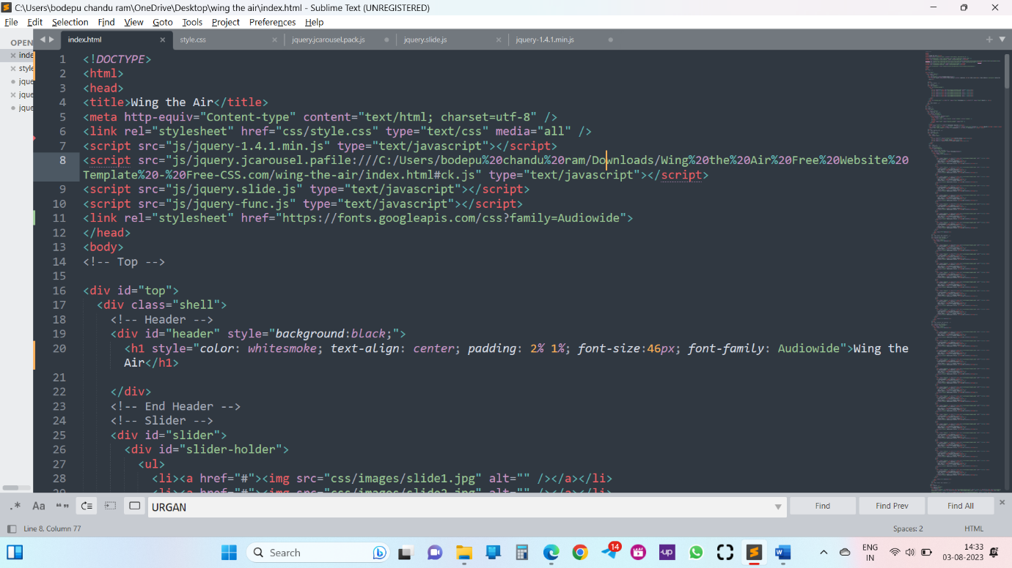
* CSS: Stylesheet language for defining the website's appearance. 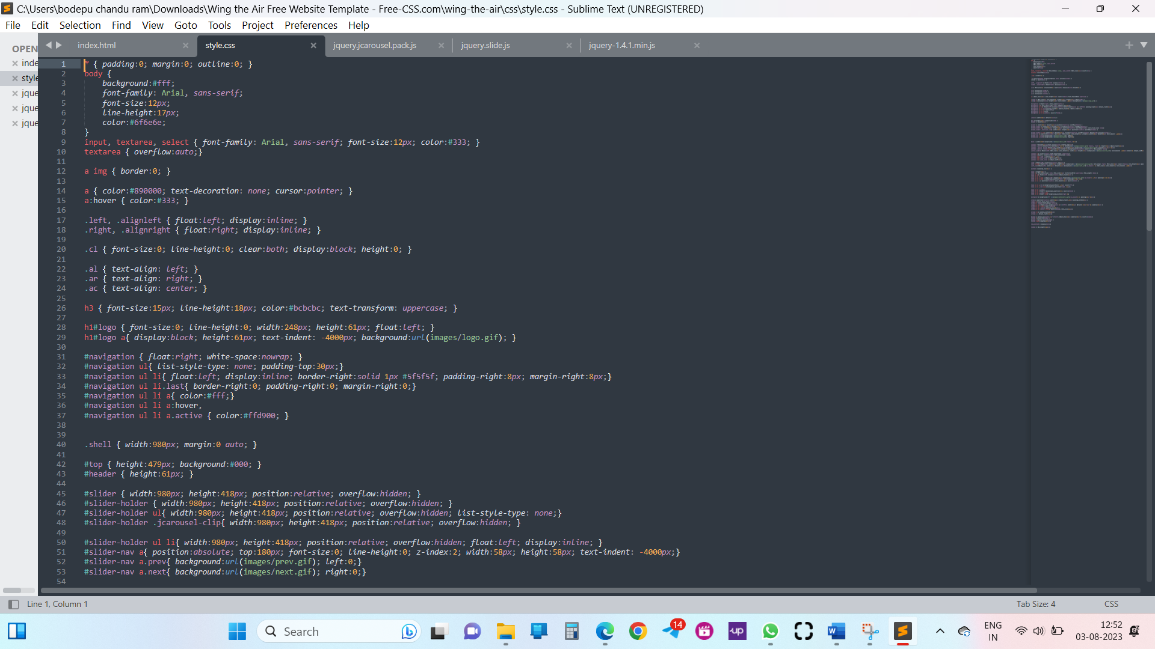
* JavaScript and jQuery: Used for creating interactive elements and slider functionality. 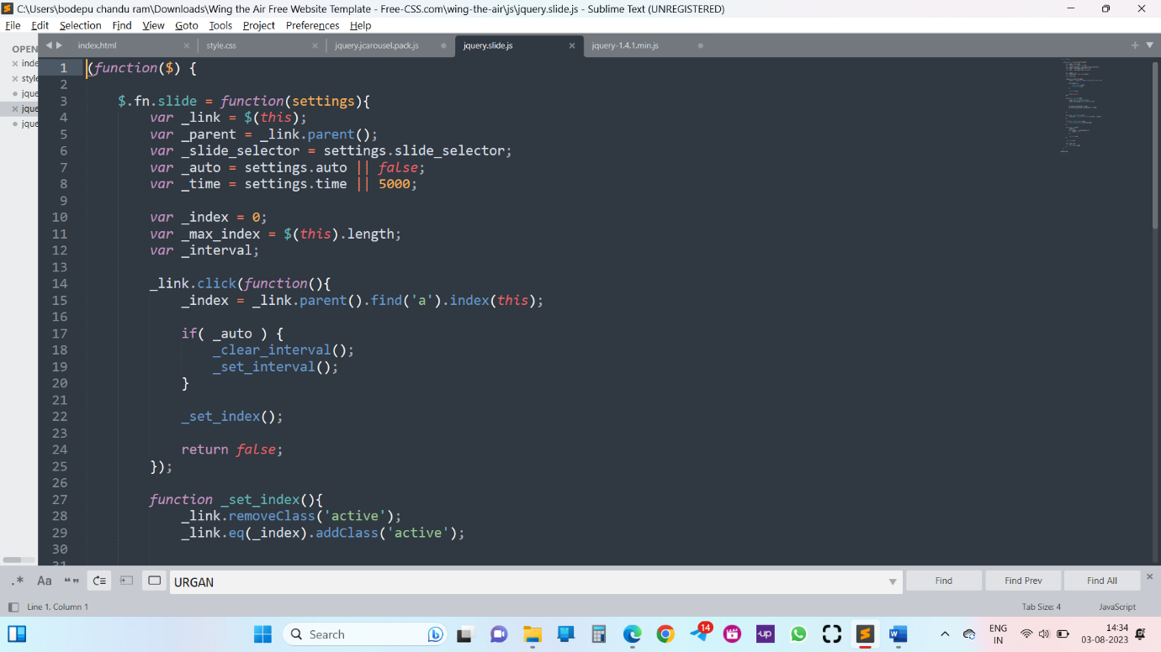

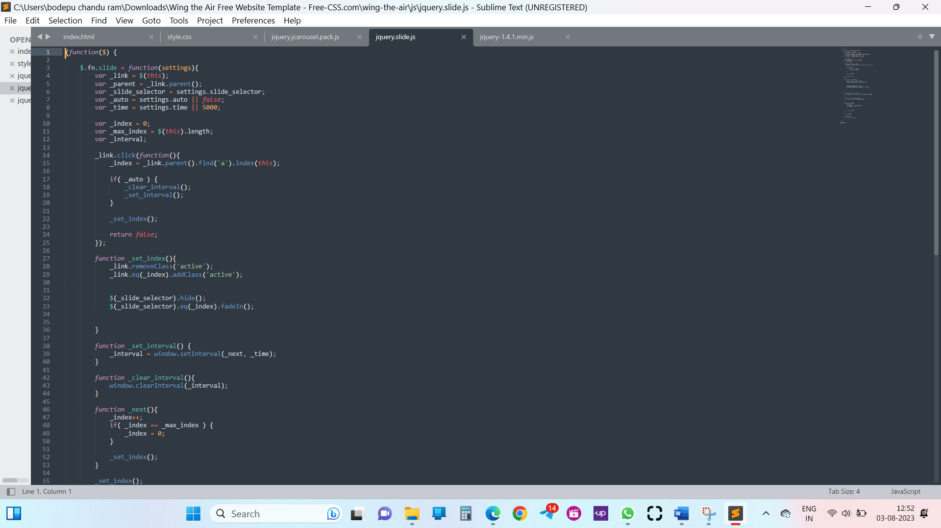

* Responsive Design: Ensuring the website is mobile-friendly and works well on various devices.

**4. Website Structure:**

1. Top Section:

* Contains the website logo and the "WING THE AIR" brand name.
* Displays a slider with featured product images.

2. Main Section:

* Options Bar:

Provides a search bar for product search.

Offers links for advanced search, cart, checkout, and details.

* Content Section:

Contains tabs for "Safety Shoes," "Sport Shoes," and "More Shoes."

Each tab displays a list of products with images, item number, size list, brand name.

3. Brands Section:

* Displays logos of different shoe brands.

4.Footer:

* Contains links to essential pages like Home, Support, My Account, The Store, and Contact.
* Includes copyright information and credits to the design source.

5. Functionality Overview:

* Slider:

Cycles through featured product images.

Previous and Next buttons allow users to navigate through images.

6.Tabs:

* Displays different shoe categories.
* Allows users to switch between categories and view relevant products.

7.Search:

* Users can search for products by entering keywords in the search bar.
* The advanced search link provides more search options.

8.Cart:

* Users can add products to the cart for purchasing.
* The cart icon displays the total amount in the cart.

9.Product Details:

* Clicking on a product image or brand name displays the product details.
* Product details include item number, size list, brand name, and wholesale price.

10.Brands:

* Displays logos of different shoe brands for brand recognition.

**6. Project Timeline:**

* Gathering Requirements: [Start Date] to [End Date]
* Design and Development: [Start Date] to [End Date]
* Testing and Bug Fixing: [Start Date] to [End Date]
* Deployment and Launch: [Start Date] to [End Date]

**7. Conclusion:**

The Wing the Air online store is designed to provide customers with an enjoyable shopping experience. The website features an appealing design, easy navigation, and essential functionalities for searching and purchasing shoes. With proper testing and deployment, the online store will be ready to launch and serve customers worldwide.

**Project structure:**

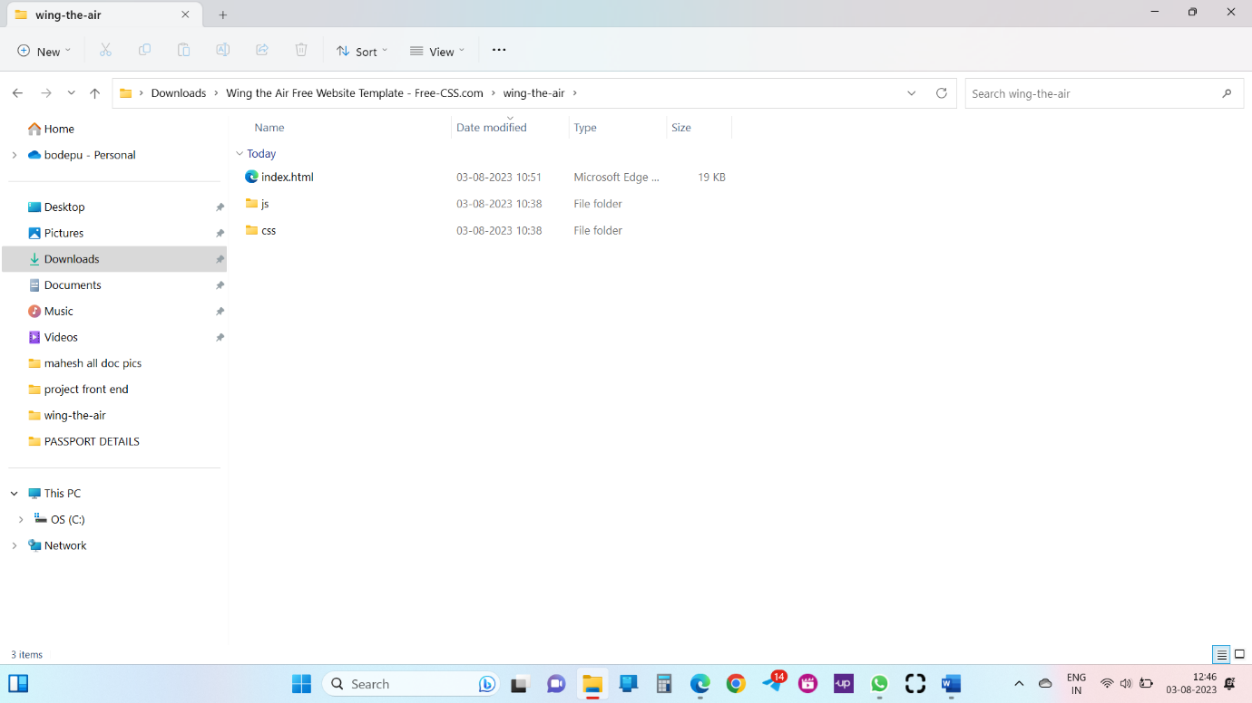

1. index.html:

This is the main HTML file and serves as the homepage for the website. It includes the header, slider, search bar, tabs for different types of shoes, and the main content section.

2. css folder:

* style.css: This CSS file contains the styles for the entire website, including the layout, colors, and typography.
* images folder: This folder contains all the images used in the website, such as product images, logos, and slide images for the slider. 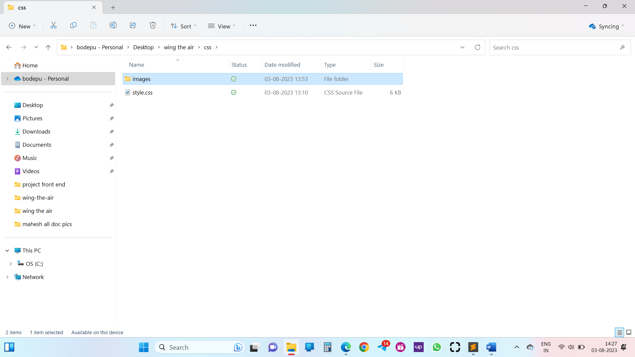

3. js folder:

* jquery-1.4.1.min.js: This is a minified version of the jQuery library, a JavaScript library used for various interactive functionalities on the website.
* jquery.jcarousel.pack.js: This JavaScript file is for the carousel/slider functionality.
* jquery.slide.js: This JavaScript file might be for handling sliding effects or animation.
* jquery-func.js: This JavaScript file likely contains custom JavaScript functions used throughout the website. 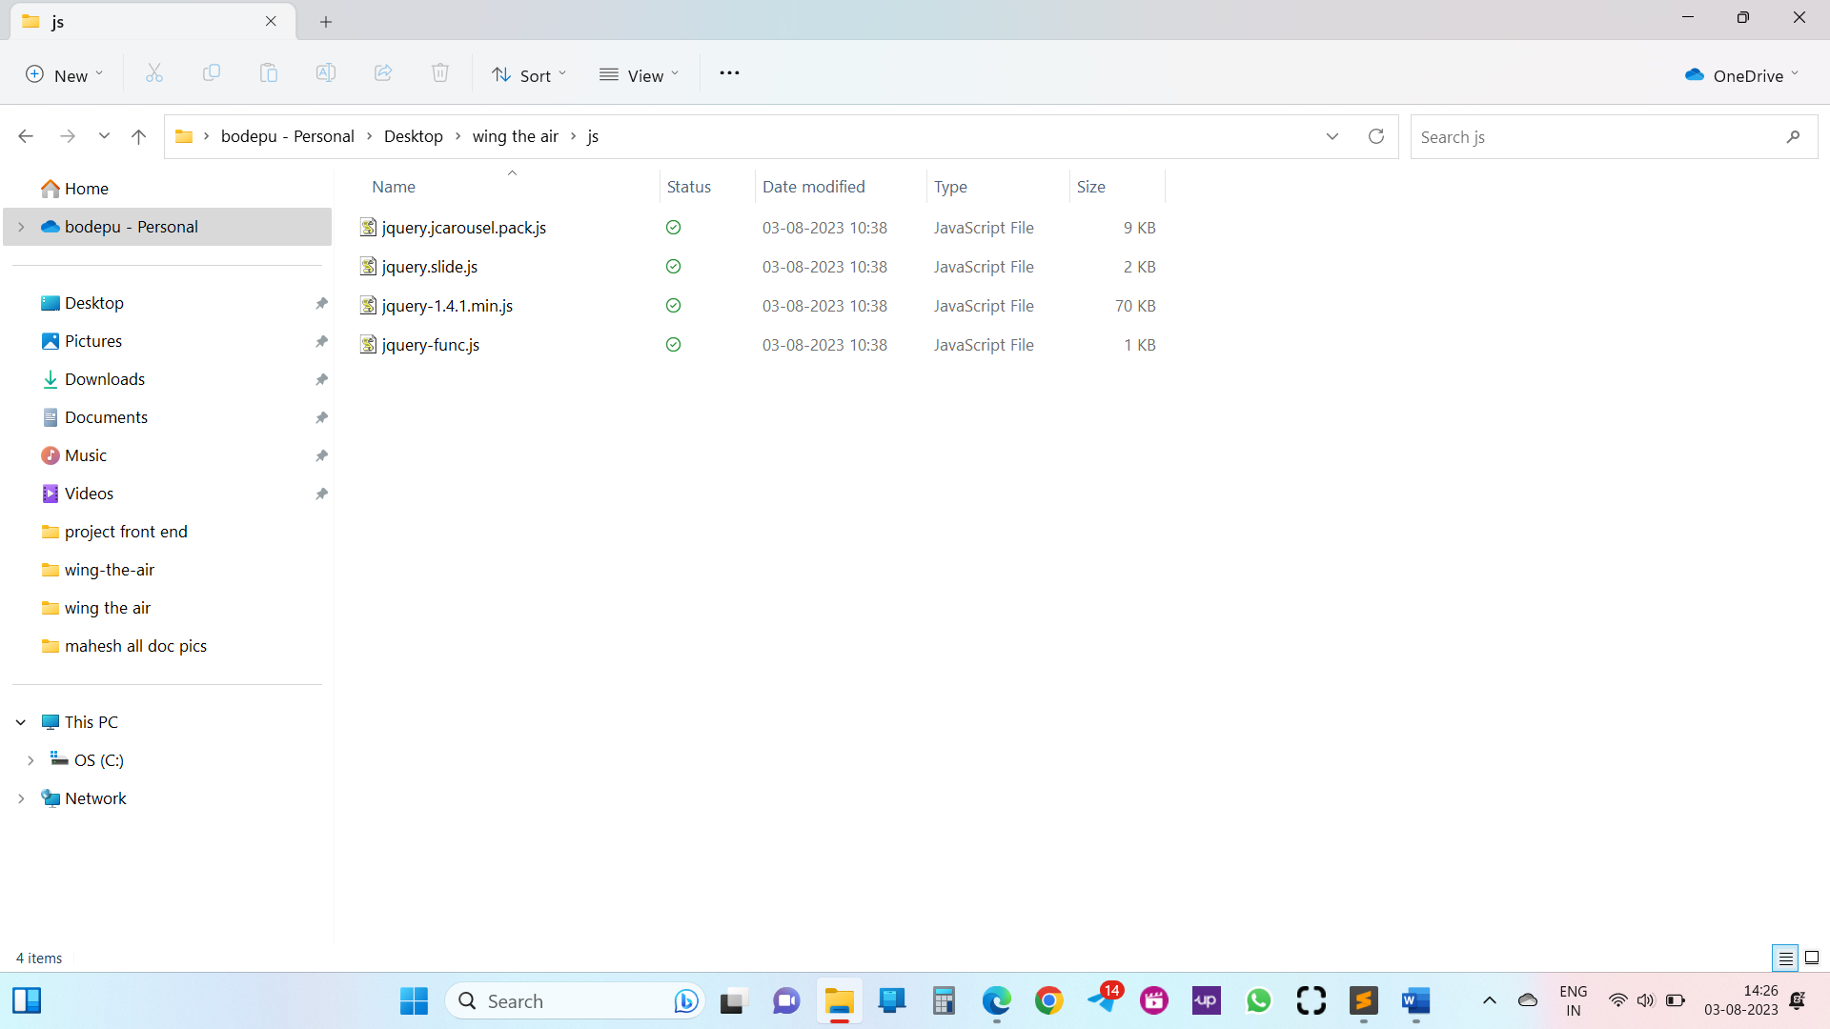

4. Top Section:

This part includes the website header, which displays the logo of "WING THE AIR."

5. Slider Section:

This section contains an image slider that cycles through different shoe images to showcase products.

6. Main Section:

* Search and Options: The options section includes the search bar, advanced search link, shopping cart, and checkout and details links.
* Content: This is the main content area that displays the shoes categorized into tabs (Safety Shoes, Sport Shoes, and More Shoes). Each tab contains a list of shoe items with their images, item numbers, size lists, brand names, and wholesale prices.

7. Footer:

The footer section displays links for Home, Support, My Account, The Store, and Contact. It also includes copyright information and credits for the website's design.

8. Brands Section:

This section displays the logos of different brands available on the website.

**Set Up The Project Structure:**

Introduction:

Setting up a well-organized project structure is crucial for managing and maintaining a web development project efficiently. A clear project structure ensures that code, assets, and resources are organized logically, making it easier for team members to collaborate and maintain the project over time. In this document, we'll outline the recommended project structure for a web development project.

1.Root Directory:

Create a root directory for your project and give it a meaningful name. This directory will contain all the files and subdirectories for your project.

2.CSS, JS, and Images Directories:

Inside the root directory, create separate directories to store your CSS, JavaScript, and images files. For example:

* css/
* js/
* images/

3.HTML Files:

Place your HTML files directly in the root directory or create a separate "html" folder to store all the HTML files. Use descriptive names for your HTML files to make it easy to identify their purpose.

4.Vendor Libraries:

If your project includes third-party libraries or plugins, create a "vendor" directory to store them. This way, you can keep your project-specific code separate from external dependencies.

5.Assets Directory:

Create an "assets" directory to store other project assets like fonts, icons, and any other static files.

6.Project Configuration Files:

Keep project configuration files, such as package.json (for npm), package-lock.json (for npm), yarn.lock (for yarn), or any other configuration files in the root directory.

7.CSS Preprocessor (Optional):

If you're using a CSS preprocessor like Sass or Less, consider creating a separate directory for your preprocessed CSS files.

For example:

* css/
* styles.css (output file)
* sass/ (source files)

8.JavaScript Module Bundler (Optional):

If you are using a JavaScript module bundler like Webpack, create a configuration file (e.g., webpack.config.js) in the root directory to manage the bundling process.

9.Build Directory:

Create a "build" or "dist" directory to store the compiled and optimized files for deployment.

10.Documentation and Assets:

If your project includes any documentation, create a "docs" folder to store it. Additionally, create an "assets" folder within the "docs" folder for any media assets used in the documentation.

**Design and Implement the User Interface**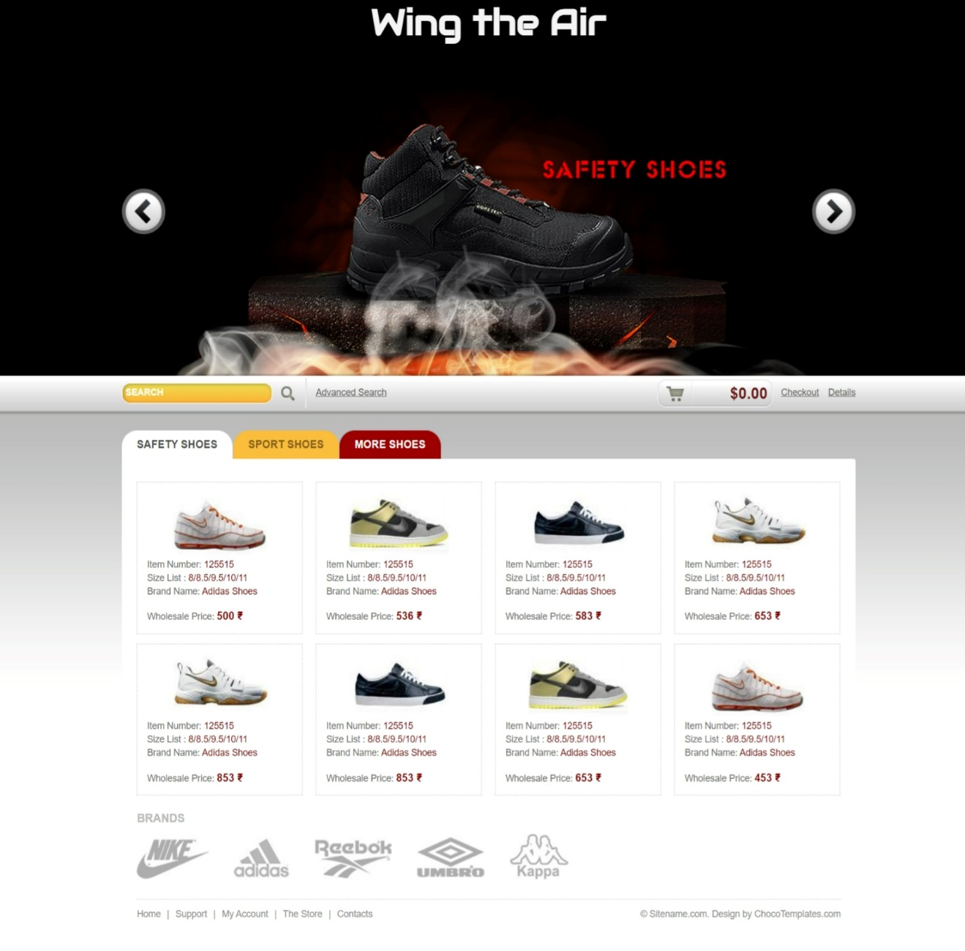

1. Introduction:

"Wing the Air" is an e-commerce website that sells shoes, particularly safety shoes, sport shoes, and other types of shoes. The goal of the website is to provide a user-friendly interface that allows customers to easily browse and purchase shoes.

2. User Interface Design: The user interface design focuses on creating an intuitive and visually appealing website layout that enhances the user experience. Here are the key elements of the user interface:

* 2.1. Header Section:The header section contains the logo of the website, which is linked to the homepage. It should be placed at the top of the page for easy visibility.
* 2.2. Navigation Menu: The navigation menu allows users to access different sections of the website. It should include links to categories like "Safety Shoes," "Sport Shoes," and "More Shoes." These links will lead users to the respective shoe categories.
* 2.3. Search Bar:A search bar allows users to quickly search for specific shoes or brands. Users can enter keywords and click the "GO" button to initiate the search.
* 2.4. Slideshow Banner:A slideshow banner showcases featured shoes, promotions, or new arrivals. The banner will automatically rotate through different shoe images with clickable links to the product pages.
* 2.5. Product Tabs:The product tabs section displays different categories of shoes available for purchase. Each tab represents a category, such as safety shoes, sport shoes, and more shoes. The active tab should be highlighted.
* 2.6. Product Listing:Under each product tab, there will be a list of shoes belonging to that category. Each shoe will have an image, item number, size list, brand name, and wholesale price. Users can click on the image or brand name to view the detailed product page.
* 2.7. Brands Section:The brands section displays logos of different shoe brands sold on the website. Each logo will be clickable and lead users to a page showcasing all the products of that particular brand.
* 2.8. Cart and Checkout:The user interface should display a cart icon that shows the total value of the items added to the cart. Clicking on the cart icon will take users to the checkout page where they can complete their purchase.
* 2.9. Footer:The footer contains links to important pages like "Home," "Support," "My Account," "The Store," and "Contact." It also includes copyright information and credits for the website design.

3. Implementation:

The user interface can be implemented using HTML, CSS, and JavaScript. Here are some guidelines for implementation:

* Create an HTML file and include the necessary HTML tags for the structure of the page.
* Use CSS to style the page layout, fonts, colors, and other visual elements. Utilize CSS to create responsive design to adapt to different screen sizes and devices.
* Use JavaScript/jQuery to implement dynamic elements such as the slideshow banner and product tabs with their respective content.
* Organize the product information in a database or JSON file to easily retrieve and display the product listings dynamically on the page.
* Implement links and navigation functionality to ensure seamless user interaction across the website.